Name | ID | STUDENT SIGN
MD. SHOHANUR RAHMAN SHOHAN | 22-46013-1 | Shohan
Class Test 01
Hogwarts is a school of witchcraft and wizardry. To ensure proper management of their data the renowned school has decided to maintain a database system. Out of many bidders your company was hired to accomplish the task. Your job is to create a relational database for Hogwarts from the requirements specified below:
RDBMS- Oracle 10g
Language-SQL
Log in as User System and create a user Dumbledore who has password Phoenix. Dumbledore is granted unlimited tablespace. He is also granted the permission to create tables. After logging in with his username and password Dumbledore creates two tables i.e. Student and House. Student table has five columns containing information about students Identification Number, Name, CGPA, Blood Status and House Number. House table has three columns containing information about House Number, House Name and House Points. Here S_Id, H_Id are the primary key columns of Student and House table respectively. Student table also has a foreign key column H_No. Constraint should be applied in such a way that CGPA cannot be greater than 4.00 and House name cannot be NULL. The two tables along with their inserted data are given below:
H_Id | H_Name | H_Points
11 | Gryffindor | 892
22 | Hufflepuf | 785
33 | Ravenclaw | 789
44 | Slytherin | 850
Table: Student Table: House

S_Id | S_Name | S_CGPA | S_BloodStatus | H_No
2 | Harry | 3.45 | Halfblood | 11
7 | Ron | 3.01 | Pureblood | 11
12 | Hannah |  | Pureblood | 22
17 | Cedric | 3.78 | Pureblood | 22
22 | Cho | 3.55 | Muggleborn | 33
27 | Luna | 2.89 |  | 33
32 | Draco | 3.88 | Pureblood | 44
37 | Goyle | 2.10 | Pureblood | 44

After creating the tables and inserting data based on provided requirements write Queries (Write down the question and also the answer. Give screenshot of the result of the query.You can add more Answer Box if required) according to the following specification:

-using ARITHMETIC operator
-using CONCATENATION operator
-using COLUMN ALIAS
-using LIKE operator
-using IS NULL operator
-using ORDER BY clause
-using SUBSTR function
-using NVL function
-using MAX function
-using SUM function
-using GROUP BY clause
-using HAVING clause
Answer:
- ARITHMETIC
Q. Show the percentage CGPA of each student?
SELECT S_Name, S_CGPA, S_CGPA * 100 AS Percentage FROM Student;

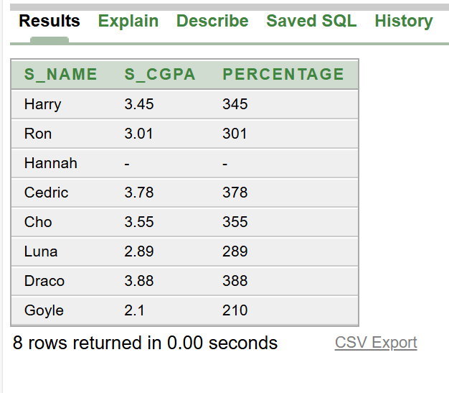

Answer:
- CONCATENATION
Q. Show the student information (ID, Name, and Blood Status) in a single string format?

SELECT S_Id, S_Name || ' - ' || S_BloodStatus AS Student_Info FROM Student;

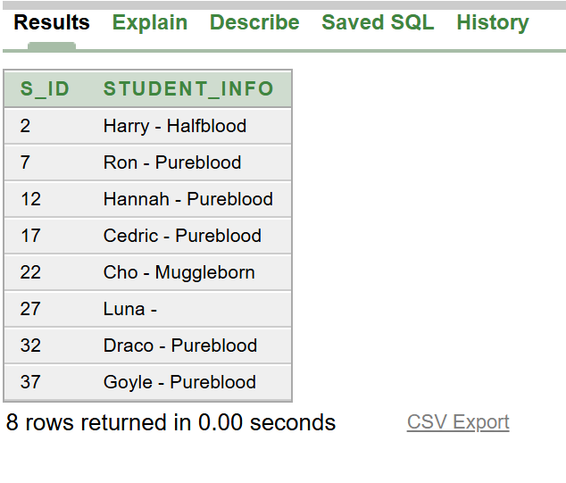

Answer:
- COLUMN ALIAS
Q. Show the student IDs and names, with appropriate column aliases?

SELECT S_Id AS Student_ID, S_Name AS Student_Name FROM Student;

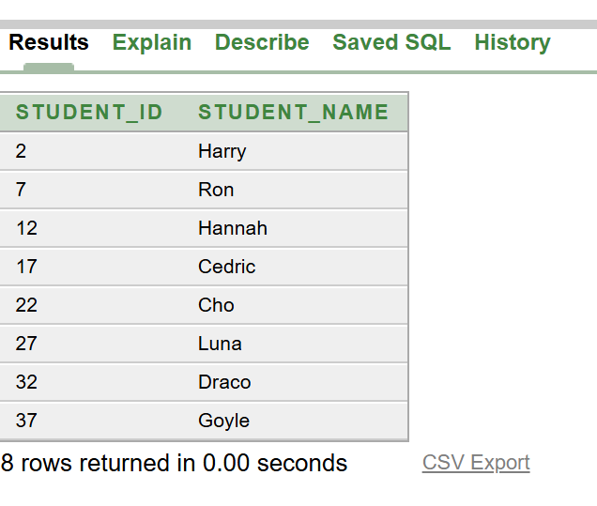

Answer:
- LIKE
Q. Show the students have names that start with the letter 'H'?

SELECT * FROM Student WHERE S_Name LIKE 'H%';

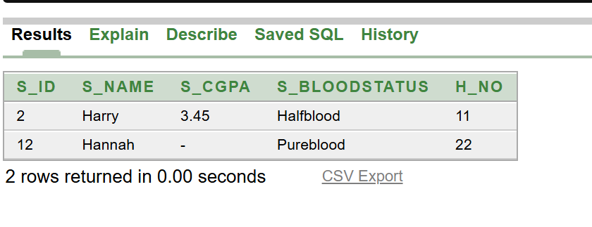

Answer:
- IS NULL
Q. Show the students have a NULL value for their blood status?

SELECT * FROM Student WHERE S_BloodStatus IS NULL;

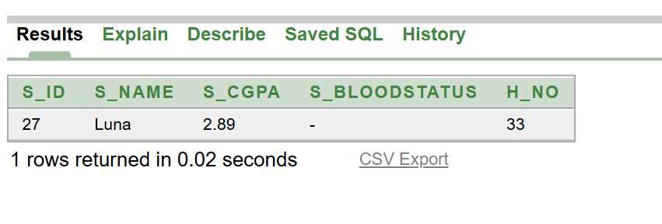

Answer:
6. ORDER BY
Q. Show the list all students ordered by their CGPA in descending order?

SELECT * FROM Student ORDER BY S_CGPA DESC;

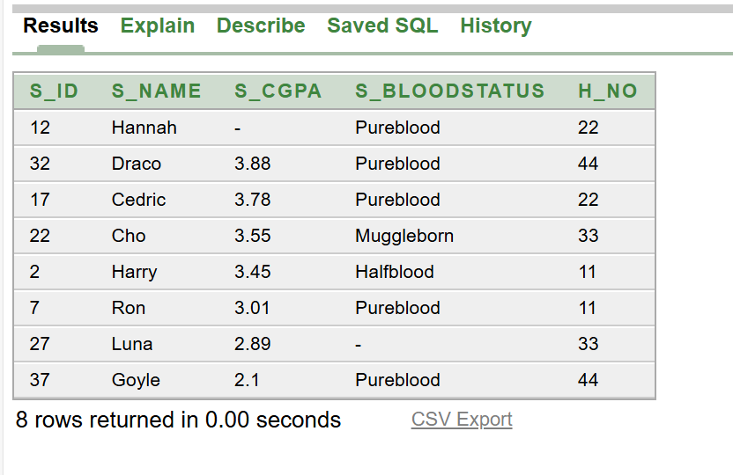

Answer:
7. SUBSTR

Q. Show the first three characters of each student's name along with their ID?

SELECT S_Id, SUBSTR(S_Name, 1, 3) AS Short_Name FROM Student;

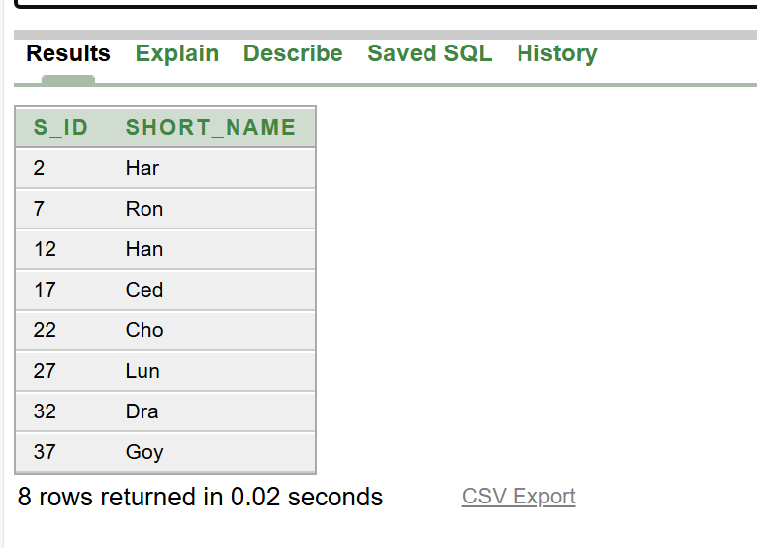

Answer:
8. NVL

Q. Show the student IDs, names, and CGPA values, replacing NULL CGPA with 0?

SELECT S_Id, S_Name, NVL(S_CGPA, 0) AS CGPA FROM Student;

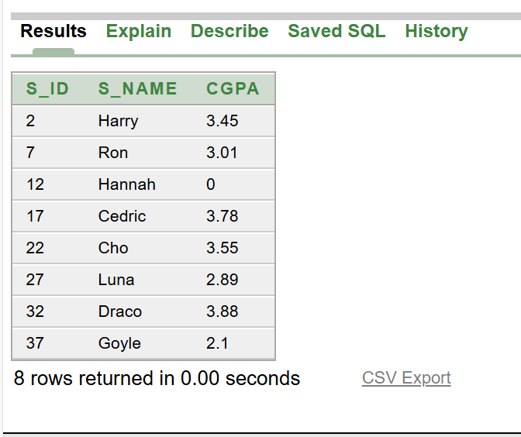

Answer:
9. MAX

Q. Show the highest CGPA among all students?

SELECT MAX(S_CGPA) AS Highest_CGPA FROM Student;

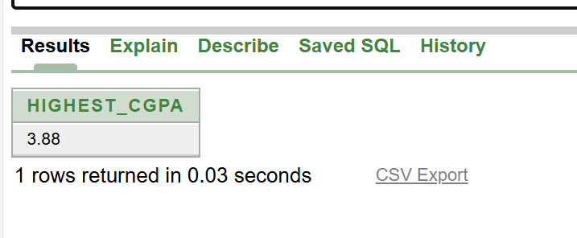

Answer:
10. SUM

Q. Show the total number of house points across all houses?

SELECT SUM(H_Points) AS Total_House_Points FROM House;

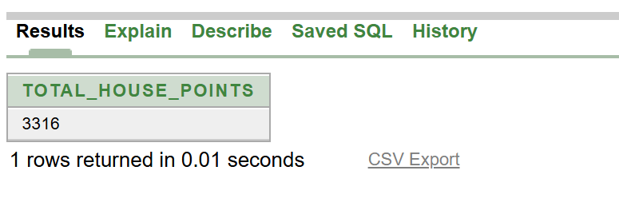

Answer:
11. GROUP

Q. Show their how many students belong to each house?

SELECT H_No, COUNT(*) AS Number_of_Students FROM Student GROUP BY H_No;

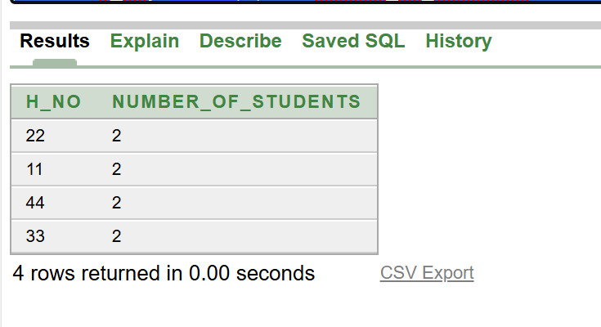

Answer:
12. HAVING

Q. Show which houses have more than 1 students?

SELECT H_No, COUNT(*) AS Number_of_Students
FROM Student
GROUP BY H_No
HAVING COUNT(*) > 1;



